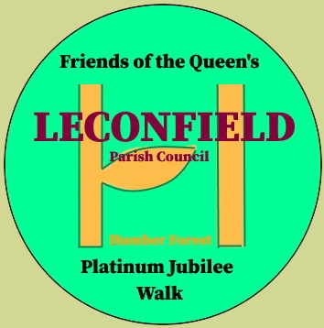
QUEEN’S PLATINUM JUBILEE WALK and
CORONATION SENSORY GARDEN GROUP

MEMBER’S NEWS SHEET (No.2/23)

To date a total of 21 residents have joined the group, but I believe many more will once more and more residents enjoy these facilities.
Should any of your friends, family or neighbours wish to join, membership forms can be obtained from and returned to Byre Cottage, Castle Farmhouse, Main Street. Tel number is 01964 551985 and Email: thomashoultby@gmail.com

Being a member is not onerous or costly, just support when available any events such as coffee mornings, etc or occasionally help to maintain the walk.
Leconfield Parish Council have allocated a regular annual sum for the maintenance of the walk and woodland which includes regularly mowing of the grass walkways; the grass between the trees will be allowed to grow and in time turn to meadowland, with the spring bulbs that have been planted spreading.

On SUNDAY MORNING, July 2nd 2023 from 10 am to 12 all are welcome to join in the weeding and tidying up of the walk and garden, and especially to help with the major job of laying 2 paths and planting the ornamental grasses.
Please bring any tool you wish, spade, fork, trowel, or especially just yourself.
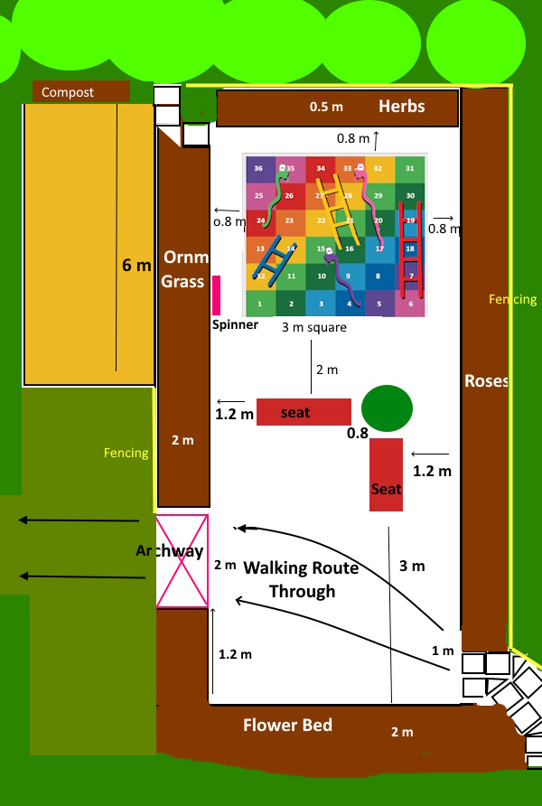
Two seats have been purchased for the garden, one by
the Parish Council in memory of Ken Brookes, who
worked for many years on behalf of the parish and
one from grants raised by the LecRec Committee.

We have also received a grant of £100 from the
Parish Council to purchase Ornamental Grasses.

A local resident has donated the Flagstones for the
footpaths and Leconfield Primary School have
donated multi coloured fencing to go round.

Travis Perkins donating building materials

It is so pleasing to see the residents of Leconfield creating the sensory garden and working on the QPJWalk for the future environment of all.

Last week TVR who planted the woodland came and weeded out the white protectors around the saplings as part of their 5 year maintenance programme.
I am pleased to report that only 2 substantial trees need watching as they are still dormant, BUT not dead.

TESCO Blue chip award


The Queen’s Platinum Jubilee Walk and Coronation Sensory Garden has been nominated to take part in their Beverley Supermarket award in ……………….
(JULY, AUGUST, SEPTEMBER) for purchasing plants etc
We are guaranteed £500 if 3rd, or even £1000 or £1,500 if more successful.
So remember to place your blue chips carefully in our section and tell all your friends.

RSPB… A bird identification board will be placed on the walk close to the future children’s area next to the new walk in from the field.
The new walk it is hoped will encourage children to gain access to the established woodland to play without passing over the newly planted bulbs and saplings.

ANY PLANTS
This is your walk so feel free to plant any spare bushes or perennial cuttings you may have when thinning out or just acquired cheap.

WILDFLOWER AREA
In October we are planning to scarify the far end of the woodland and spread British wild flowers to create a colourful meadow.

Thank you, Tom Houltby (June 2023)

