Leconfield Parish Council – Traffic & Safety Summary
Date of Meeting: Thursday, 14 August 2025
Location: Leconfield Village Hall, Miles Lane, HU17 7NW

Summary of Key Issues Discussed
• Speeding at village entrances (Main Street – Driffield & Beverley entrances, Arram Road, Miles Lane)
• Safety concerns near the children’s play park on Miles Lane
• School access and pedestrian safety on Grange Road and Old Road
• Crossing safety on Main Street
• Inconsistent or unclear speed limits and signage (e.g., Grange Road)
• Parking issues near St Catherine’s Church during events
• Requests for give way markings

Vehicle Speeds
As discussed during the meeting, our compliance tool data provides insights into traffic speeds. When integrated with Speed Watch information, these resources offer a comprehensive overview of local conditions. Analysis reveals several locations where the data profile shows the higher vehicle speeds exceed posted limits at the village entrances, Reassuringly, the speeds are generally within the enforcement thresholds although I will request some targeted enforcement from the Roads Policing Unit.
Grange Road demonstrates a discrepancy between average speeds and those at the 85th percentile, indicating specific challenges in this area. Community Speed Watch findings and anecdotal reports highlight ongoing community concerns about speeding, particularly involving tractors and local drivers.
We also demonstrated the publicly available crash map and explained how our enhanced version informs intervention strategies. It is worth noting that the centre of the village maintains a strong safety record, which, while positive, makes it more challenging to design new interventions in that area.
NOTE: We would like to extend our sincere gratitude to the Speed Watch team for their invaluable contributions. It makes a huge difference.

Crossings
There is a prevalent misconception that a signal-controlled crossing is inherently safer. This is not the case. Both signal-controlled and zebra crossings can achieve similar safety standards if matched appropriately to their environment. If mismatched, safety may decrease.
Signal-controlled crossings often benefit drivers more than pedestrians and may not be ideal in locations on routes used by children or teenagers, who can be impulsive and may not wait for the green signal before crossing. Drivers may proceed with less caution when signals are present, which is a proven effect and has resulted in fatalities, hence our caution.
Leconfield’s current choice of crossing type prioritizes pedestrian safety, especially for children, by encouraging vigilance and interaction rather than reliance on signals alone. There is no pattern of pedestrian-vehicle collisions at the crossing, which supports the appropriateness of the current design. Of course, minor vehicle shunts may occur at any crossing type, but pedestrian safety remains the primary concern.
In addition, innovative technologies are emerging to monitor crossing usage and behavior. We are engaging with several tech companies to trial systems that claim to be able to record usage data (vehicle and pedestrian) and detect near misses. This initiative is in its early stages and will require rollout, baseline data collection, and testing before yielding actionable insights. We recognize its importance and assure the community that it is on our collective radar.

Play Park Entrance
The Parish has proposed relocating the entrance. If it would be useful, we can supply any of our speed compliance and usage data for funding applications. Relocation is considered the optimal solution, as the current layout is not ideal in terms of sightlines.

School Entrance
The School Streets initiative was explained and appears to be technically viable. Further investigation will determine actual feasibility, which depends on the willingness of road users to engage with it. If there is interest, the head teacher should apply for School Streets. Comprehensive information is available online, and the responsible officer can assist.

Grange Road
The area is not fully adopted, and there are historic discrepancies relating to its prior use as the main entrance of the army base. Traffic Regulation Orders (TROs) and signage require review. We propose including this in a broader investigation. Although TROs are expensive, most costs are fixed legal fees, allowing for potential economies of scale.

Parking near St Catherine’s Church
Following a careful assessment, we cannot support establishing a formal parking area at this location. While vehicles currently park informally, formal designation would compromise pedestrian safety by obstructing footpaths and encouraging road walking. Additionally, the area is a service strip, and so would require assessing its load-bearing capacity and potentially upgrading infrastructure. Should an alternative parcel of land be identified, funding for parking facilities may be possible, though challenges are anticipated.

Give Way Markings
We explained how, as with many things in traffic management, behavioural psychology is a prevalent element, making a lot of things counterintuitive. In the case of signs and lines, while people think ‘more signs = more information = safer roads,’ the reality is more subtle.
The primary information that drivers use (albeit subconsciously) is what we call the roadside environment (e.g., the difference between a motorway and a housing estate). As engineers, we focus on exploiting this effect to enhance safety. The key factor in areas with a large number of pedestrians is to avoid creating the cues of a traffic-centric environment.
The more signs and lines there are, the more drivers get the subconscious message that they are in a place for cars. They feel safer and less cautious, so they drive faster and with less care. By removing these cues, we get better behavior – the drivers (understandably) dislike it, but that dislike translates to a significant drop in speed (5mph+ in some studies) and an increase in awareness of the surroundings.
Also, there is a limit to how much visual information a driver can process, and so we get a cognitive overload effect if there are too many signs; critical messages can get overlooked. For this reason, we would not introduce any further markings or signs – especially as we have a good safety record – any change can only make it worse.

Actions and Next Steps
• Add a holistic review of village speeds to the 2026/27 forward programme and investigate signage and TRO status on Grange Road. This includes but not limited to
- Consideration of buffer zones when entering the village from both Beverley & Driffield
- Review of Miles Lane
- Review of Grange Road
In parallel, there is a growing body of national evidence supporting the effectiveness of 20mph zones in enhancing road safety and creating more liveable communities. Reflecting this momentum, East Riding is currently piloting 20mph schemes at four locations within the area. These trial sites will be carefully monitored and analysed over the next 18 months, with local findings considered alongside emerging national best practice. Insights from this evaluation will play a crucial role in shaping and refining policy on lower speed limits in East Riding, ensuring that future decisions are led by robust evidence and tailored to community needs.
• Contact the Road Policing Team regarding potential red route designation

Attached
• Speed Compliance reports
• SID (Speed Indicator Device)

Crashmap
https://www.crashmap.co.uk

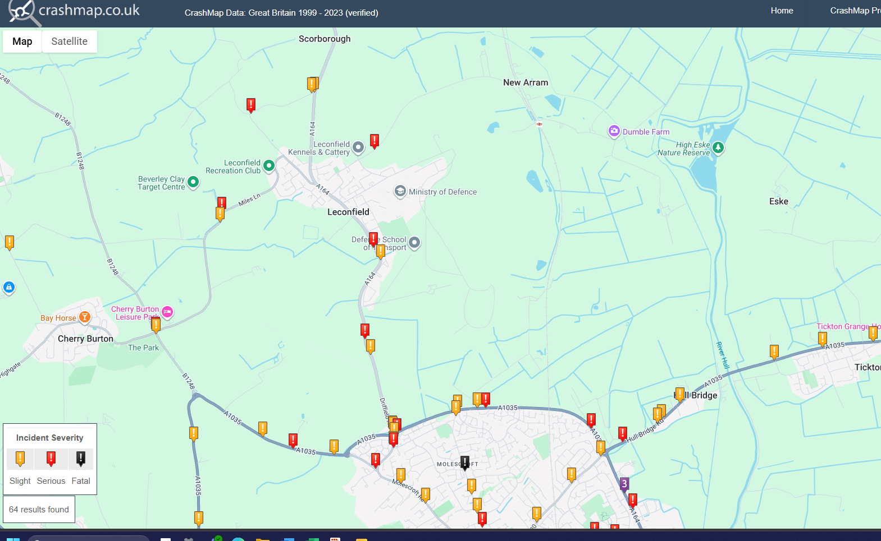

School Streets
Some useful links:

School Streets: how to set up and manage a scheme - GOV.UK

School Streets East Riding

